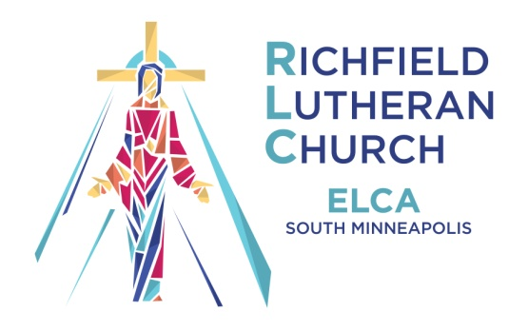
The R.L.C. Mid-Week News: 06/23/2021
“Together we will BE the church by living out God’s gifts
in the community and the world”
8 West 60th Street, Minneapolis, MN 55419-2553
Phone: 612.861.2265 Website: www.richfield-lutheran.org

Eased Restrictions for In-Person Worship July 2021
GOOD NEWS!
RLC Has Returned To Weekly Worship Sundays @ 9:15 a.m. With Newly Eased In-Person Requirements for Everyone!

Effective July 04, 2021, The 9:15 service will be updated as follows for in-person worship:
No masks required for fully vaccinated people
No social distance seating
Yes, there will be congregational singing.
***new*** Yes, there will be individual cup Holy Communion offered the first and third Sunday of each month, starting July 04.
Yes, will ask that you continue to do contact tracing sign in – at least for a little while.
No, Passing the Offering Plate, Sharing the Peace or Fellowship Coffee at this time - but we look forward to adding that in later this summer!
So.... if you are ready – please join us this Sunday as we continue to evolve into post-pandemic worship at RLC! And if not, you can continue to engage in weekly worship at one of our online or audio options listed below.
CLICK HERE FOR: VIDEO WORSHIP VIA RLC's YOUTUBE CHANNEL

AUDIO WORSHIP VIA DIAL-A-SERMON
CALL: 612-474-4974
CLICK HERE FOR: The 10:45 MONTHLY "SUMMER ART & SCRIPTURE" WORSHIP VIA ZOOM - July 25
CLICK HERE FOR: ONLINE RESOURCES & OTHER ZOOM LINKS

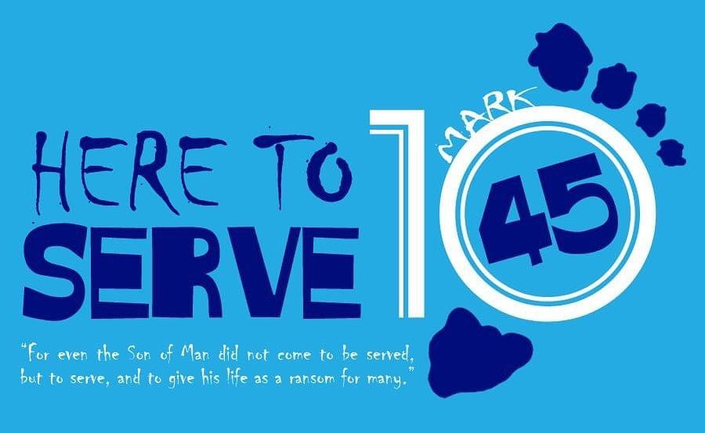
The 10:45 Worship Via Zoom Moves to Once a Month
Due to meeting schedules, graduations, vaccines and vacations – The 10:45 worship will be meeting once a month in the summer as follows – the 4th Sunday of the month online:
JUNE 27 JULY 25 AUGUST 22
Each month we will check in, spend time with scripture and view related artworks. It is our hope that starting in September, The 10:45 will resume worship in-person at RLC.
In the meantime – join us via Zoom:
https://us02web.zoom.us/j/89878480770

